Monday, 8 March 2021

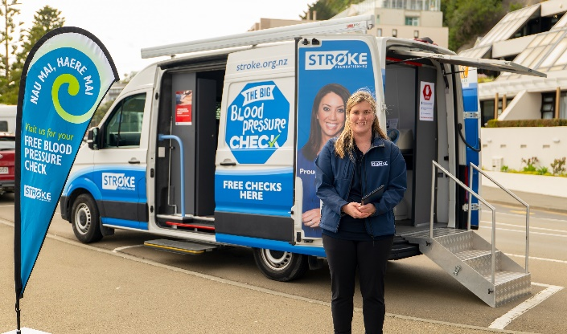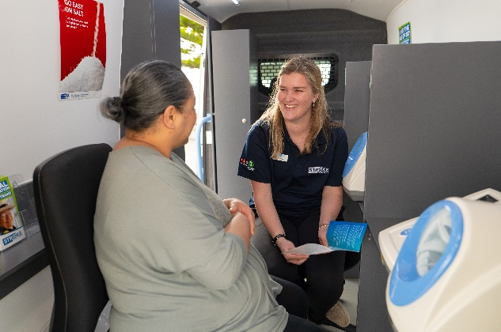

STEPS TO DRIVE OUT THE SILENT KILLER – THE BIG BLOOD PRESSURE CHECK VAN HITS THE SOUTH ISLAND
- Get your blood pressure checked at various PAK’nSAVE and New World supermarkets

The Stroke Foundation of New Zealand’s Big Blood Pressure Check Van is set to begin travelling the South Island from 8 March through to 24 March. Travelling from Marlborough to Invercargill, free blood pressure checks will be offered as part of an effort to ensure that all New Zealanders have access to a free check at least once a year.

Sponsored by Ryman Healthcare, the Wellington based Big Blood Pressure Check Van last hit the South Island in 2018. Following the success of the trip, which provided 3,055 free blood pressure checks and informed thousands of New Zealanders about the link between high blood pressure and stroke, the van is back. The van will be on the road for a month and in partnership with Foodstuffs, will be visiting various PAK’nSAVE and New World supermarkets across the region.

High blood pressure puts strain on all the blood vessels throughout the body including the ones in the brain, which can result in a stroke. As high blood pressure doesn’t usually have any symptoms, the only way to know if you have high blood pressure is to get tested.

Julia Rout, Stroke Foundation Health Promotion Manager said: “Research shows over 11,000 people are predicted to experience a stroke this year. By investing in stroke prevention initiatives, more lives will be saved. The van will allow us to visit communities across the South Island and share important information about stroke and stroke risk factors, helping to reduce the number of people impacted by stroke.

High blood pressure is manageable and can often be controlled efficiently through lifestyle changes and if necessary, medication. We know that the van has been a successful prevention initiative to date, offering over 15,000 free blood pressures in the last two years.”

Check out our website for a full list of testing sites: https://www.stroke.org.nz/big-blood-pressure-check-vans

Our team will be adhering to the Government and Ministry of Health Alert Levels and will only operate this service if it is safe to do so.

- ENDS -
Media enquiries:
Stroke Foundation of New Zealand
Lauren Ellis, Media and Communications Advisor, Lauren.ellis@stroke.org.nz / 027 506 9822

About the Stroke Foundation of New Zealand
The Stroke Foundation is the national charity in New Zealand solely dedicated to the prevention of and recovery from stroke. For over 40 years, we have actively promoted ways to avoid stroke and dedicated ourselves to working closely with stroke survivors, their family / whānau and carers. The generosity of New Zealander’s enables us to help thousands of stroke survivors every year; providing them with critical services to ensure the best possible outcomes - not just for themselves, but also their family / whānau and carers too. Three quarters of strokes are preventable, so we will continue our vital awareness campaigns and health promotion programmes - saving thousands of lives. To find out more about the important work the Stroke Foundation does go to www.stroke.org.nz

The Stroke Foundation commissioned the New Zealand Institute of Economic Research to understand the social and economic cost of stroke to New Zealand in 2020: https://www.stroke.org.nz/stroke-foundation-and-nzier-research

